



Integrated Office Applications
(215)

NATIONAL 2024

PRODUCTION
Job 1: Spreadsheet __________ (230 points)
Job 2: Database __________ (250 points)
Job 3: Letter __________ (100 points)
Job 4: Database/Mail Merge __________ (100 points)
TOTAL POINTS __________ (680 points)

Test Time: 90 minutes

GENERAL GUIDELINES:
Failure to adhere to any of the following rules will result in disqualification:
- Member must hand in this test booklet and all printouts if any.
- No equipment, supplies, or materials other than those specified for this event are allowed in the testing area. No previous BPA tests and/or sample tests (handwritten, photocopied, or keyed) are allowed in the testing area.
- Electronic devices will be monitored according to ACT standards.

EXAM GUIDELINES:
- Ensure this test booklet contains Jobs 1-4.
- Key all jobs according to the instructions given.
- Correct any and all formatting, spelling or grammar errors. Use the formatting guide in the Style & Reference Manual.
- Your name or initials should not appear on any work you submit. Use your Member ID in any occasion you would normally key your reference initials.
- In the lower right-hand corner of ALL work submitted (unless otherwise specified), key your Member ID and job number.
- If you complete the event before the end of the time allotted, notify the proctor. Time may be considered a factor in determining a winner when there is a tie score.
- Place your scoring sheet on top of your jobs. Jobs should be placed in numerical order.

PRODUCTION STANDARDS
0 Errors | 100 Points
1 Error | 90 Points
2 Errors | 70 Points
3 Errors | 50 Points
4+ Errors | 0 Points

Job 1 - Spreadsheet | Possible Points | Points  Awarded
Data input correctly (follows production standards)  0 errors – 100 points, 1 error – 90 points, 2 errors – 70 points, 3 errors – 50 points, 4+ errors – 0 points | 100
Autofit all columns to contents | 5
All information in Row 1 Bold | 5
Use a VLOOKUP formula using the information in columns J & K to return the correct base salary for each position | 20
Calculate 401k match column. 5.5% of base salary | 5
Enter 12,375 for all positions for Health Insurance | 5
Enter 5,450 for all positions for Life Insurance | 5
Calculate total benefit package | 5
Format information in columns D:G number with Comma style, 0 decimals | 5
Format column H as Accounting number format, 0 decimals | 5
Calculate totals for columns D:H in row 45 as Accounting number format, 0 decimals, Bold | 5
Member ID# and Job# in right footer | 5
Print in Landscape orientation (fit to one page if needed), with gridlines | 10
Print w/formulas
Landscape, gridlines, fit to one page, A1:H45 only | 5
VLOOKUP formula correct | 25
401k match formula correct | 10
Total Benefit package column formula correct | 5
Total Formulas in Row 45 correct | 5
Job 1 Total | 230
Job 2 - Database
Query
Query contains Department, Position, Base Salary, and 401k match fields | 20
Information Technology and Human Resources Departments only | 15
Sorted by Position, alphabetic order | 5
All information is visible | 5
Query Name is correct with Member # | 5
Job 2 Query Printout 1 | 50
Create report Named Information Technology and Human Resources Departments using all fields in the query | 10
Group by department | 10
Alphabetize by position, ascending | 10
Add Avg summary options for base salary and 401k match | 5
Stepped layout, Portrait orientation | 5
Member # is subheading underneath report name | 5
All labels/information are visible | 5
Eliminate summary data in department footer | 5
Change Avg label to Average | 5
Change 401k average to Sum, Add label ‘Total 401k Match’ under Average | 10
Align average and total numbers with columns they represent | 10
Bold, italicize total/average labels and amounts | 10
Change total/average amounts to currency format, 0 decimals | 10
Job 2 Report Printout 2 | 100
Job 2 Total | 150
Job 3 – Letter (this will be printed in Job 4)
Production Standards  0 errors – 100 points, 1 error – 90 points, 2 errors – 70 points, 3 errors – 50 points, 4+ errors – 0 points | 100
Job 3 Total | 100
Job 4 – Database/Mail Merge
Data input correctly (follows production standards)  0 errors – 50 points, 1 error – 45 points, 2 errors – 35 points, 3 errors – 25 points, 4+ errors – 0 points | 50
Database printout, 1 page, landscape, all information visible | 20
Printout of letter with Merged Codes | 20
Printout of Kerry O’Connor letter | 10
Job 4 Total | 100
TOTAL | 680

Job 1: Spreadsheet

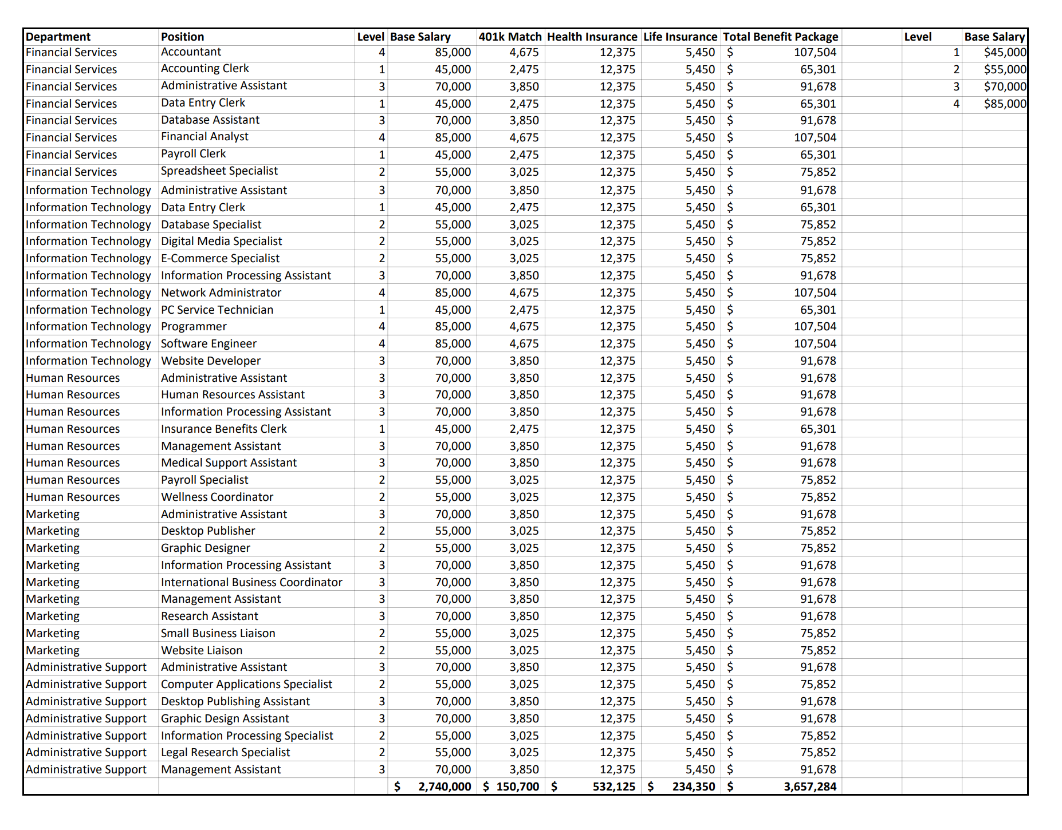

Printout with formulas

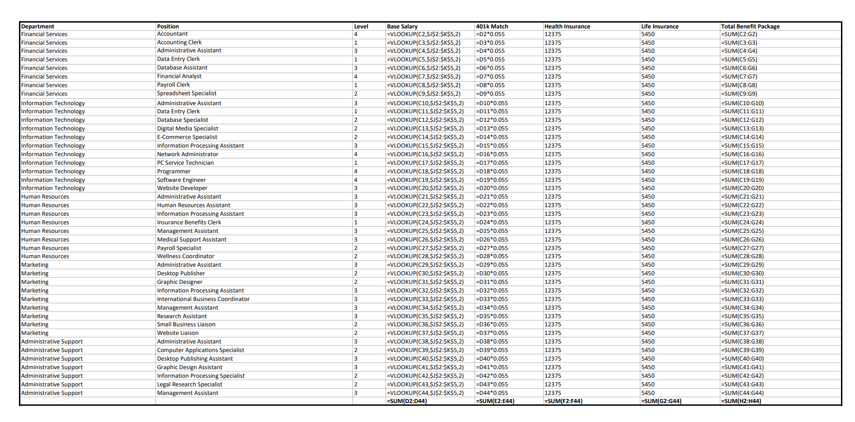

Job 2: Database

Printout #1 Query

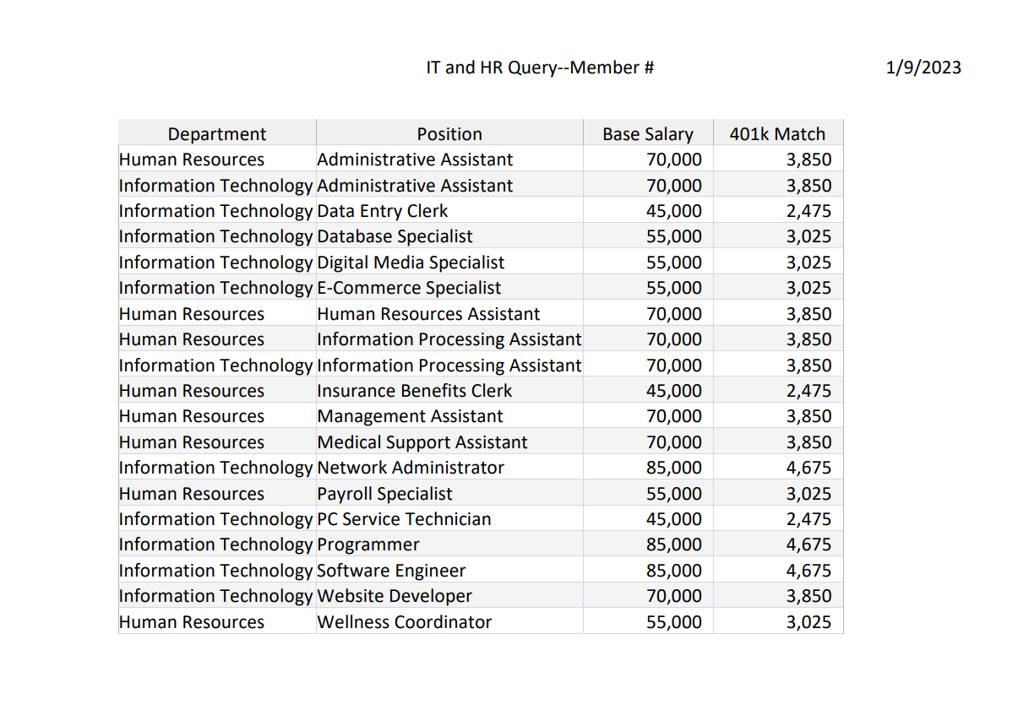

Printout #2 Report

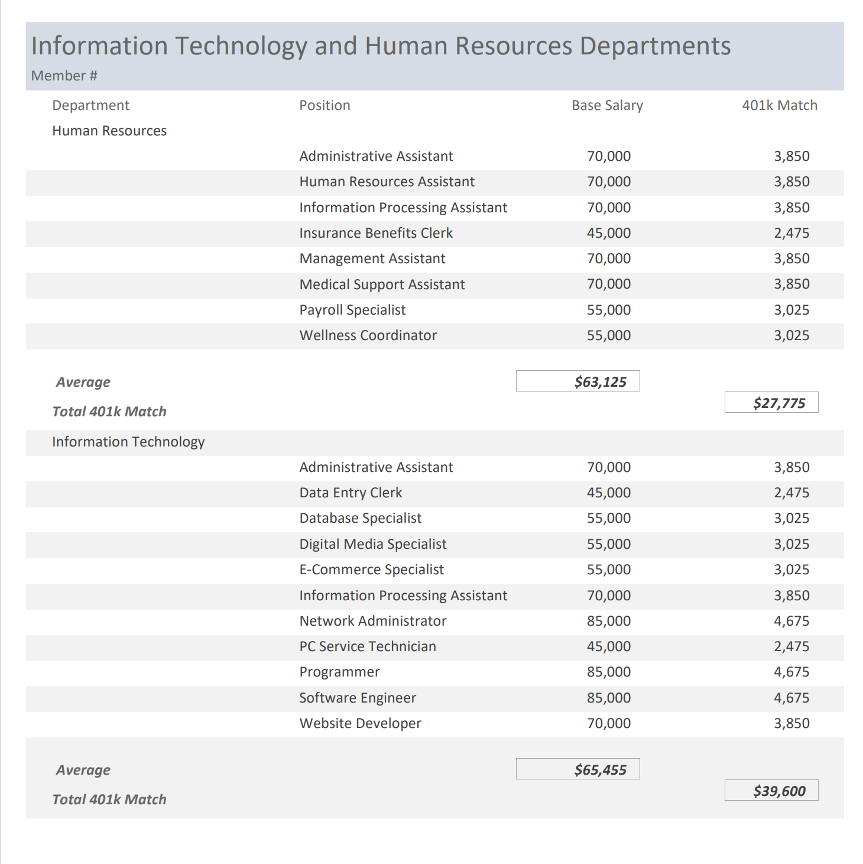

Job 3: Letter—Will be printed in Job 4

Job 4: Database/Mail Merge

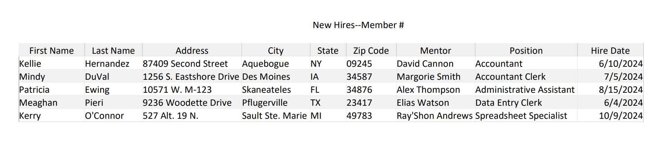
Printout with Merge Codes:

Current date

«First_Name» «Last_Name»
«Address»
«City», «State» «Zip_Code»

Dear «First_Name»

Please make sure you complete all of the enclosed IT and health insurance forms one week prior to your hire date of «Hire_Date» as we need to make sure we have ample time to get your badge, email, log in and passwords created so you are ready to go on Day 1. You have been assigned «Mentor» as your mentor during your 3-month probationary period. Your mentor will be meeting with you from 10-11:30 a.m. on your first day.

If you have any questions prior to your hire date with your paperwork, please contact the Human Resources department 888-125-6512. Any other questions, please call our main number at 888-125-1000 our receptionist will be able to direct your call. We cannot wait to see you on «Hire_Date»!

Sincerely

Julie Smith
Human Resources Department Manager

######### (Member ID)

Enclosures

c Harvey Rosen

Printout for Kerry O’Connor

Current date

Kerry O'Connor
527 Alt. 19 N.
Sault Ste. Marie, MI 49783

Dear Kerry

Please make sure you complete all of the enclosed IT and health insurance forms one week prior to your hire date of 10/9/2024 as we need to make sure we have ample time to get your badge, email, log in and passwords created so you are ready to go on Day 1. You have been assigned Ray'Shon Andrews as your mentor during your 3-month probationary period. Your mentor will be meeting with you from 10-11:30 a.m. on your first day.

If you have any questions prior to your hire date with your paperwork, please contact the Human Resources department 888-125-6512. Any other questions, please call our main number at 888-125-1000 our receptionist will be able to direct your call. We cannot wait to see you on 10/9/2024!

Sincerely

Julie Smith
Human Resources Department Manager

######### (Member ID)

Enclosures

c Harvey Rosen

